EXERCISE 1: Write 10 testing ideas for each of the products below:

1. Vending Machine with Cold drinks. You should be able to pay with real money and debit/credit cards. It should be   
   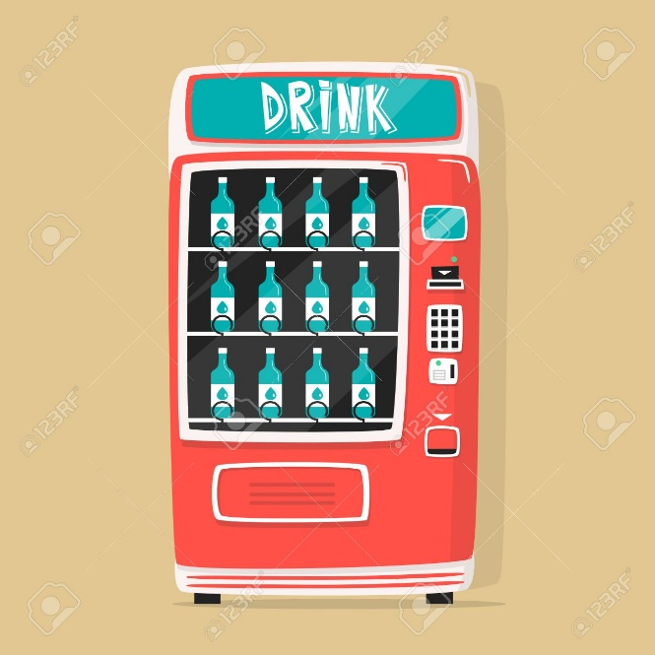
2. ATM – the ATM accepts all kind of debit and credit cards.  
   